Ethical Hacking Microsoft learn - Introduction
I criminali informatici hanno molteplici risorse, con la quale possono minare la CIA:
- Confidentiality: Information should only be visible to the right people. Refers to the need to keep confidential sensitive data. You can encrypt data to keep it confidential, but then you also need to keep the encryption keys confidential Confidentiality is the most visible part of security
- Integrity: Information should only be changed by the right people or processes, so Integrity is about having confidence that data hasn't been tampered with or altered. Refers to keeping data or messages correct. Encrypting data keeps it confidential, but you must then be able to decrypt it so that it's the same as before it was encrypted.
- Availability: Information should be visible and accessible whenever needed. It's important to the organization to keep customer data secure, but at the same time it must also be available to employees. It might be more secure to store the data in an encrypted format, employees need access to decrypted data.
THREAT LANDSCAPE → Entry point for cybercriminals: Email accounts, Social media accounts, Mobile devices, the infrastructure, Cloud services, People (Human Vector, Social engineering)
ATTACK VECTORS → Hackers common attack vectors: Removable media (infected USB) Browser (change settings)
Cloud services (gain control of any source) Insiders (social engineering)
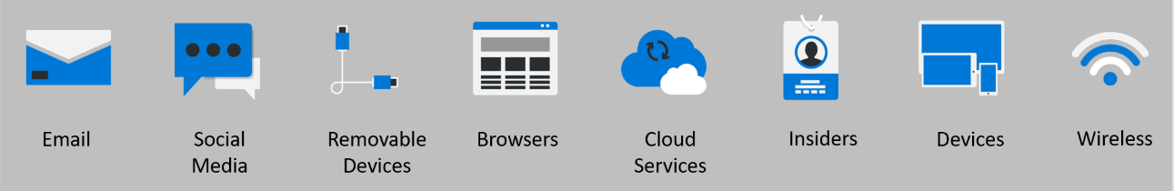
Security breaches → break-in, an attacker breaks into a building (dev, app or net). There are differents type:
Social engineering attacks → when a system appeared totally secure (zero vulnerabilities) actually social engineering allows attackers to steal credential and gain access to the system as a admin or user (impersonification attacks)
Browser modified attacks → Hackers can use the browser to steal information, monitor user behavior or compromise a device
Password attacks → Brute forcing principally
Data breaches → An attacker successfully gain access or control of data
Malware (Malicious Software) has two main components:
- Propagation mechanism → Virus/Worm/Trojan:
- Virus: In biology, a virus enters the human body, so can spread. at the same way IT virus can contaminate the system
- Worms: doesn’t need user action, spread across devices in the same, or connected, networks and cause damage by finding vulnerable systems it can exploit.
- Trojan: fake softwares that pretend to be known ones, but they secretly performs malicious action (such as steal info)
- Payload mechanism → Ransomware/Spyware/Botnet
- Ransomware: locks system and encrypt data, until the victim has paid a ransom
- Spyware: spies on device or system, keyboard scanning for collect passwd details and transmit them back to others
- Backdoors: payload that enables to exploit a vulnerability to bypass existing security measure and cause harm
- Botnet: a bot army, devices that can be remotely controlled to carry out some nefarious actions (crypto mining)
MITIGATION STRATEGIES → Ways to contrast cyberattack
MULTI FACTOR AUTHENTICATION → Users have multiple forms of identification, such as fingerprint or retinal scan (biometric), or something that the user has, such as mobile, hardware key, or trusted device.
BROWSER SECURITY → Prevent the installation of unauthorized add-ons and browsers, blocking suspicious sites, always on update, against cyberattacks.
EDUCATE USERS → human vulnerability is the most expose: identify suspicious message and never give personal info to externals, lock devices and store, share, remove data only according to the organization's policies
THREAT INTELLIGENCE → Threat landscape can be vast: monitor, prevent, defend against attacks, and even identify possible vulnerabilities before cybercriminals use them to carry out attacks. collect systems information, details about vulnerabilities, information on attacks and more, so can implement policies for security, devices, user access, and more, to defend against cyberattacks. All these processes can be automated, the primary object is alway CIA.

CYBER SECURITY → any preventative measure that protects information or processes from being stolen or compromised
Types of cybercriminals:
- Criminally-motivated attackers want to steal something for their own gain, such as money or data.
- Politically-motivated attackers seek attention and may often make their attacks known to the public. This type of cyberattack is often referred to as "hacktivism."
- Personally-motivated cyber criminals often try to disrupt a company's systems for retribution. These attackers are usually current or former employees.
Types of attacks:
- Active → aim to alter the targeted system by affecting the CIA of data
- Passive → find out as much information as possible about their target in hopes of leading to a breach of privacy
ZERO TRUST → never trust, alway verify (end-to-end security strategy, controls the six main pillars of security):
- Identity → Endpoints → Applications → Network → Infrastructure → Data
Zero trust has 3 principles (except never trust always verify):
- Verify explicitly → continuous / multiple levels of access, ID verification constant monitoring
- Apply least privilege access → Just-in time (JIT) / Just-enough access (JEA) minimized the access
- Assume breach → rules for limiting access to an hacker that’s already inside the network
Common attack vectors:
- Email → phishing
- Social media → gain access to information and resource about ID
- Removable devices → USD, smart cables or staìorage cards can contain malicious code
- Browsers → using by hackers for change user’s settings to provide an entry point, by downloading malicious code
- Cloud services → hackers can gain access to important organization source
- Insiders → social engineering act by hackers or human actor can open a breach by mistake
- Devices → can cause a network plague
- Wireless → Cyber Criminals often tap into unsecured wireless networks to look for vulnerabilities

Most common types of attacks:
DDoS (Distributed Denial-of-Service) → caused by several request by several devices or protocol
MITM (Man-in-the-Middle) → attackers that can manipulate the traffic between two or more devices
Ransomware → encrypt all data that can be decrypted only paying moner to cybercriminals (usually crypto values)
Phishing → asking for personal information from individuals (usually by mail)
Vishing → similar to phishing, but by Voice (for example shitty call center)
Smishing → similar to phishing and vishing, but uses SMS
Password attacks → Brute Forcing, recognition, keyboards trackers…
Malware attacks → most common type, malicious software used to breach a network through vulnerabilities, Spyware for ex.

MALWARE → Malicious software, infect the organism thanks to propagation mechanism and act by payload
PROPAGATION MECHANISM
- Viruses → Viruses need an end user to perform some type of action so the virus can infect the system, they depending on an entry point to begin causing harm
- Worms → Worms find system vulnerabilities and exploit them to cause damage and may sit on top of legitimate applications that have access to a system. Once the application is launched, the worm begins to spread across devices in the same network or in connected networks.
- Trojan → A trojan pretends to be a genuine piece of software, but actually it's secretly performing malicious acts in the background like stealing information.
Payload → the action that malware performs on an infected system or device Ex Ransomware, Spyware, Backdoors, Botnets
Mitigation → set of steps an organization takes to prevent a cyberattack (reduces severity, seriousness or painfulness)
- Multi Factor authentication (MFA) → works by requiring users to provide more forms of identification
- Browser security → doing regular update, blocking certain sites and being careful about add-ons
- User education → human vector is the most important for social engineering
- Threat intelligence and detection → collect every info about all cyber attacks of all time for mitigation
Prevention devices → software well known for securing networks: WE USECRYPTOGRAPHYTOO
- Firewall → network security device that put rules for filters incoming and outgoing network traffic
- VPN → create an encrypted tunnel from an IP to another
- Antivirus software → works by using detection, identification, and removal of threats
- Routine updates → against newly discovered vulnerabilities and exploits
SHARED RESPONSIBILITY (SaaS, PaaS, IaaS, on-premises data center) CLOUD COMPUTING AZURE MICROSOFT AZ-900 CERTIFICATE
Defense in-depth strategy has the goal to ensure the CIA, its work with layers provides protection. if one layer is breached, a subsequent layer will prevent an attacker getting unauthorized access to data. Example layers of security might include:
- Physical security → such as limiting access to a datacenter to only authorized personnel
- Identity and access security controls → such as multi factor authentication or condition-based access
- Perimeter → security of your corporate network includes distributed denial of service (DDoS) protection
- Network sec. → such as network segmentation and network access controls, to limit communication between resources.
- Compute layer security → securing access to virtual machines either on-premises or in the cloud by closing certain ports.
- Application layer security → to ensure applications are secure and free of security vulnerabilities.
- Data layer security → including controls to manage access to business and customer data and encryption to protect data.
ZERO TRUST MODEL has three principles which guide how security is implemented:
- Verify explicitly → Authentication of every available data point (ID, location, device, workload, data classification, anomalies)
- Least privileged access → limit user access with JIT/JEA, risk-based adaptive policies, data and productivity protection
- Assume breach → encrypted data, use analytics to get visibility, detect threats and improve the security
In the Zero Trust model, all elements work together to provide end-to-end security.
- Identities → Every identity’s interaction must be verified with strong authentication, so follow least privilege access principles
- Devices → Monitoring devices for health and compliance is an important aspect of security
- Application → The way that data is consumed, managing permissions and access, not all applications are manage centrally
- Data → Should be classified, labeled, and encrypted based on its attributes
- Infrastructure → represents a threat vector, so use telemetry to detect attacks and anomalies and take protective actions
- Networks → should be segmented, real-time threat protection, end-to-end encryption, monitoring, and analytics
Governance / Risk / Compliance (GRC)
- Governance → means a system of rules, practices and processes used to control activities
- Risk → identifying, assessing and responding to every threat or event, facing risk from both external and internal sources. Extrìernal risks come from political and economic forces, weather or pandemic. Internal risks comes from the infrastructure
- Compliance → depends by legislation, where legally mandated minimum standards are met, compliance-related concepts:
- Data residency → Data residency regulations govern the physical locations where data can be store and how to do
- Data sovereignty → Data is subject to the laws of the country in which it's physically collected, held, or processed.
- Data privacy → Providing notice and being transparent about the collection, processing, use, sharing of personal data
AUTHENTICATION / AUTHORIZATION
Authentication proved that people are for real who they pretend to be / Authorization gives access only in specific areas
The identity is the first security perimeter, because it's may be associated with user, devices, Cloud and On-premises apps
The Four pillars of an identity infrastructure
- Administration → governance of identities for users, devices and services
- Authentication → how much an IT system needs to know about an identity to have sufficient proof to allow it
- Authorization → processing the incoming identity data to determine the level of access an authenticated person has
- Auditing → tracking who does what, when, where and how, so having in-depth reporting, alerts and governance of identities
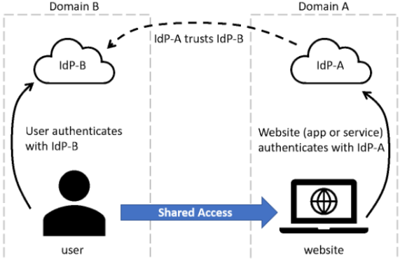
The client communicates with the identity provider by giving an identity that can be authenticated, when the identity has been verified, the identity provider issues a security token that the client sends to the server. The server validates the security token through its trust relationship with the IdP. By using the security token the id accesses the required resources on the server.
Federation and single sign-on mechanism:
- The website, in domain A, uses the authentication services of Identity Provider A (IdP-A)
- The user, in domain B, authenticates with Identity Provider B (IdP-B)
- IdP-A has a trust relationship configured with IdP-B
- AUTHENTICATION COMPLETED
Authentication can be divided into three types: something you know, something you have, and something you are.
- “Something you know” includes: Passwords, PIN numbers, Security questions
- “Something you have” includes: Identity cards, USB keys, Computers, Cell phones
- “Something you are” includes: Fingerprint, Facial recognition, Retinal scan, Biometric ID.
Authentication-based attacks are → Brute force attack, Dictionary attack, Credential stuffing, Keylogging, Social engineering
ZERO TRUST PRINCIPLES
